Question 1 Output

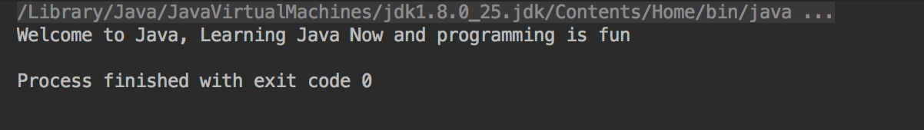

Question 2 Output

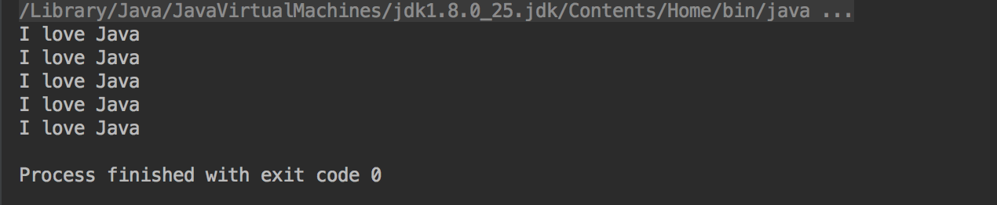

Question 3 Output

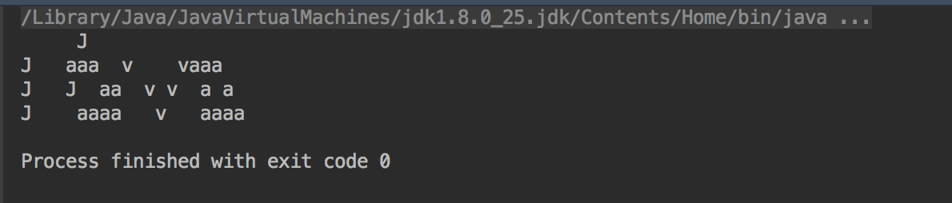

Question 4 Output

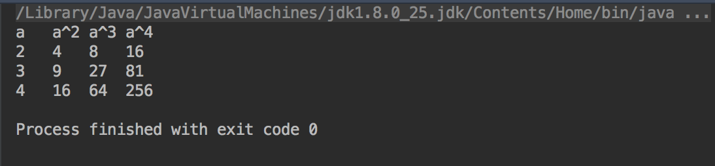

Question 5 Output

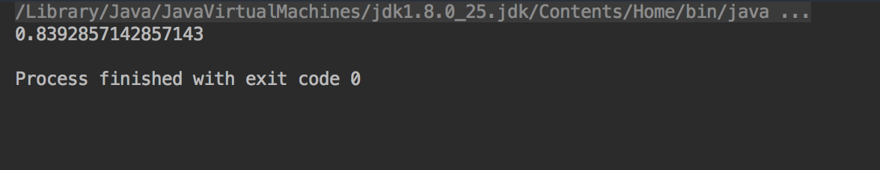

Question 6 Output

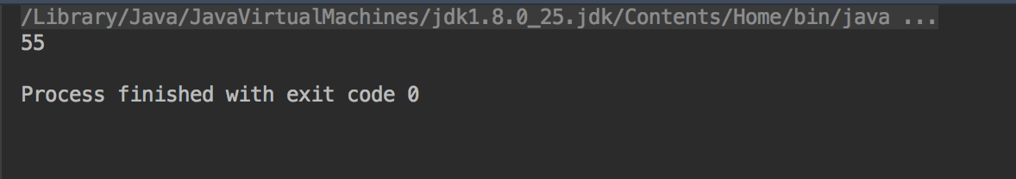

Question 7 Output

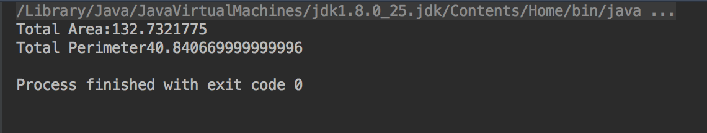

Question 8 Output

